Caracol Partners with Prototech Co. Ltd. to Bring LFAM
Technology to South Korea

MILAN, Italy, August 27th 2024 – Caracol, a global leader in large format 3D printing solutions for advanced applications, is pleased to announce a new distribution partnership with Prototech Co. Ltd, a South Korea-based player in 3D printing technology. This collaboration is set to expand the global reach of Caracol’s industrial 3D printing technology to a broader audience across Asia, with a focus on providing tailored solutions that support customers to achieve their manufacturing goals, by accessing to the latest advancements in 3D printing technology. “Our collaboration with Prototech marks a significant milestone in our global expansion strategy into the APAC region. We believe that this partnership will enable us to penetrate the South Korean market and help more businesses harness the power of advanced LFAM technology to transform their manufacturing processes.” says Caracol Global Channel Sales Director, Marco Bellini.

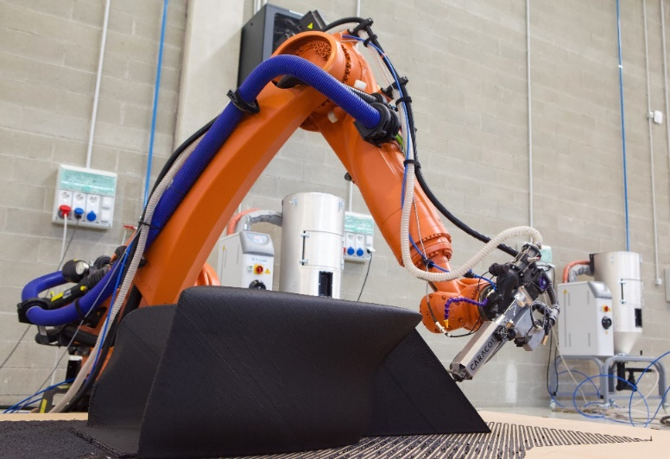
Caracol’s robotic LFAM platform Heron AM D prints a geometrically complex, large-scale tool, with Caracol’s High Accuracy extruder.
Prototech, renowned for supplying diverse 3D printing and reverse engineering services to various industrial applications, is integrating Caracol’s LFAM platforms Heron AM to expand its portfolio beyond FDM technology. “We are thrilled to partner with Caracol, a company that shares our commitment to innovation and excellence”, says Prototech CEO, Sang Mook Shin. “This partnership allows us to offer our customers a broader range of 3D printing solutions that are not only cutting-edge but also aligned with the highest standards of quality and reliability. Caracol’s FGF 3D printing platforms are recognized for their sustainability, efficiency, and ability to handle complex geometries and materials. By integrating these solutions into our portfolio, we want to driving innovation in advanced manufacturing.”

CARACOL

Caracol was founded in 2017 in Milan, Italy, with the vision of pushing the limits of additive manufacturing in terms of scale, efficiency, and sustainability. The company accomplished this by developing an integrated technological platform, including both hardware and software, to produce advanced large-scale components. Through the integration of a patented extrusion head, the development of a dedicated software, and the use of robotic arms as movement support, Caracol offers an additive manufacturing technology for advanced components for customers in industries such as aerospace, marine, energy, design, and architecture. Heron AM manufactures parts such as jigs and molds for aircraft components, finished parts for yacht and boat superstructures, or revolutionary projects to initiate virtuous circular economy processes for the energy or design sectors. Today the company has opened the largest LFAM production center in Europe, a new production facility in Austin (TX), USA opened in August 2023, and has a core team of over 80 international professionals with highly specialized competences, in areas such as mechanical engineering, automation, computational design, design for additive, and advanced manufacturing processes.

For more information, please visit the Caracol website: caracol-am.com

Press Contact:
Violetta Nespolo, Chief Marketing & Strategy Officer
E-mail: marketing@caracol-am.com

PROTOTECH
Prototech is a South Korea-based company at the forefront of 3D printing technology. With a robust portfolio of advanced 3D printing technologies, Prototech serves a wide range of industries, providing high-quality, reliable, and efficient solutions for additive manufacturing. The company is dedicated to continuous innovation and delivering cutting-edge products that meet the evolving needs of the market.

For more information, please visit the Prototech website: www.prototech.co.kr
LinkedIn: https://www.linkedin.com/company/prototech-3dprinting/

